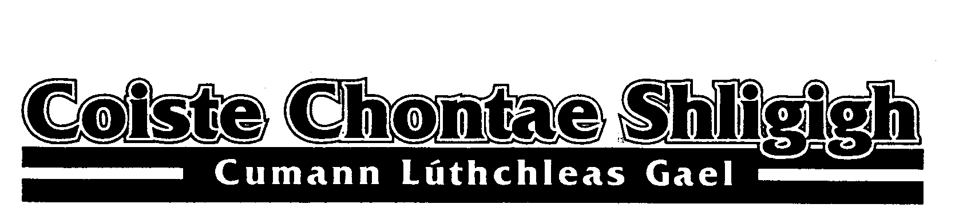

COMHDHÁIL 2020

CLUB

POSITION OUTGOING NOMINATION

CATHAOIRLEACH BRENDÁIN ÓLOININ ___________________________
(Chairperson)

LEAS CATHAOIRLEACH DEAGLÁN RÚIS ____________________________
(Vice- Chairperson)

RUNAÍ BEARNÁIRDÍN NÍCSHAMHRÁIN __________________________
(Secretary)

LEAS RUNAÍ SEÁN ÓCEARBHAILL _____________________________
(Asst. Secretary)

CISTEOIR **PEADAR ÓhUAINE _______________________________
(Treasurer)

CISTEOIR CÚNTÓIR DÁITHÍ OCOIMÍN ________________________________
(Asst. Treasurer)

OIFIGEACH CAIDREAMH POIBLI BEARTLAID Ó BEARÁIN ________________________________
(PRO)

OIFIGEACH CULTÚR & GAELIGE SEOSAMH ÓBRÁDAIGH ________________________________
(Irish & Cultural Officer)

OIFIGEACH FORBARTHA RISTEARD ÓBRAONAIN ______________________________
(Development Officer)

OIFIGEACH OILIUNA PEADAR ÓNIALLÁIN ______________________________
(Coaching Officer)

OIFIGEACH NA BPÁISTÍ TOIREALACH ÓMEARNÁIN _______________________________
(Children’s Officer)

COMHAIRLE CONNACHTA (2) DIARMUID MAG FHIONNÁIN 1)______________________
(Connacht Council)
Representatives
GEAROID ÓCONCUBHAIR 2) ______________________

ARD COMHAIRLE SEOSAMH ÓTÁIFT ______________________
(Central Council
Representative)

IONADAÍ AG COMHDHÁIL 1)_______________________
CONNACHT 2021 (4)
2)_______________________
(Representatives to 2021 Connacht
3)_______________________
Convention)
4)_______________________

IONADAÍ AG COMHDHÁIL NÁISIUNTA 2021 (4) 1) Cathaoirleach
(Representatives to National Convention 2021 2) Runaí

3)________________________

4) ________________________

Siniú: _____________________________ Runaí Chlub

Signed: ___________________________ Club Secretary

Notes: The County Children’s Officer and County Development Officer shall be appointed (not elected) at the Annual Co. Convention on the recommendation of the outgoing Coiste Chontae.
. ** Denotes officers who are ineligible to hold that particular position in accordance with Rule 3.11(b) T.O. 2020. (5 Year Rule). Please consult with all nominees and get their agreement before nominating them. Please return your nominations and motions to the County Secretary not later than 7.30pm on Wednesday November 18th 2020.
Bearnáirdín NicShamhráin, Rúnaí Chontae. Email: secretary.sligo@gaa.ie.
Bernardine McGauran
Secretary, Sligo GAA Office, Centre of Excellence, Scarden, Strandhill Road, Sligo

COMHDHÁIL 2020

MOTIONS FOR 2020 CONVENTION:

__________________________________________________________________________________________________________________________________________________________________________________________________________________________________________________________________________________________________________________________________________________________________________________________________________________________________________________________________________________________________________________________________________________________________________________________________________________________________________________________________________________________________________________________________________________________________________________________________________________________________________________________________________________________________________________________________________________________________________________________________________________________________________________________________________________________
_________________________________________________________________________________________________________
___________________________________________________________________________________________________________________________________________________________________________________________________________________________________________________________________________________________________________________________
Siniú: _____________________________ Runaí Chlub

Signed: ___________________________ Club Secretary

Please return your nominations and motions to the County Secretary not later than 7.30 p.m. on Wednesday 18th November, 2020.
Bearnáirdín NicShamhráin, Rúnaí Chontae. Email: secretary.sligo@gaa.ie.
Bernardine McGauran
Secretary, Sligo GAA Office, Centre of Excellence, Scarden, Strandhill Road, Sligo

