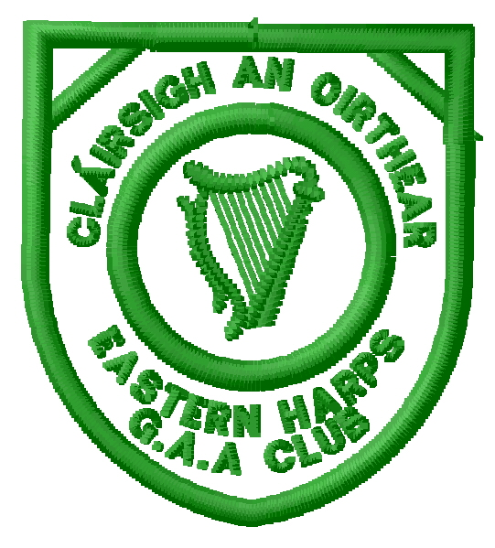
Notice of Motion

Rationale for Motion (Optional)
Proposed By * | Name (Print)
 | Signature of Proposer
Seconded By * | Name (Print)
 | Signature of Seconder

* Proposer & Seconder must be fully paid-up Members and be prepared to speak to the motion at AGM.
This form should be sent either directly to Shaun Dorrian, Secretary, Carrowcrory, Ballinafad, via Boyle, Co. Sligo or
a scanned copy (including handwritten signatures) will be accepted by email to secretary.easternharps.sligo@gaa.ie
to arrive no later than Tuesday 7th November 2017
If you would like assistance or information on how best to compose or present a Motion at the AGM, the Club Officers will be pleased to advise you before this date.

